Synopsis

Predicting Student Academic Performance

Problem Id: 27

Nidhi Bhatt
2028781
Section: K

Devashish Chauhan
2028705
Section: K

- Problem Description:
The performance of students can also be quite erratic, especially when the students are of the same capability. It can be difficult for the teacher and the parents to understand which factors, such as study habits, attendance, previous grades, and sleeping patterns, actually contribute to the performance. Without this understanding, it can result in the poor performance of students going unnoticed, and the resources available can be utilized in the wrong manner. It is, therefore, imperative to understand the factors that contribute most to the performance of the students.
This project has been designed to address this challenge by utilizing the student performance dataset, which contains various factors, including academic, behavioral, and environmental factors. It can help to identify the most influential factors and can also be used to predict the performance of individual students. It can also be used to understand which factors contribute most to the performance of the students. It can, therefore, help to address the challenge by utilizing the results, which can be achieved through the utilization of the machine learning model. It can also help to obtain a better understanding of the factors that contribute most to the performance of the students.
- Steps of Implementation:
Data Collection:
The data collected is a mix of various academic and behavioral characteristics. The characteristics include study hours, attendance, scores, tutoring sessions, sleep habits, and physical activity. Both numerical and categorical data are used for a comprehensive understanding of the students’ performance.

Data Preprocessing:
For categorical data with missing values, the most common category is used to replace the missing values. For text-based features, one-hot encoding is used to convert them into a numerical form. Numerical data is scaled to a fixed range for analysis.

Model Selection:
For predicting the scores, various machine learning algorithms were considered. The selected algorithms are Linear Regression, Decision Tree Regressor, and Random Forest Regressor. These algorithms were selected for their simplicity and ability to handle both numerical and categorical data.

Training and Validation:
For training and validating the machine learning models, the data is divided into a training set and a test set.

Evaluation:
Models were evaluated by using Mean Absolute Error, Mean Squared Error, and R² score for the best model. Feature importance and correlation were also analyzed for identifying the features that have the most significant impact on the results.

Final Model:
The best model was chosen on the basis of its accuracy and interpretability. A clean dataset was created by selecting the most important features, which would help in precise results for predicting the marks of the student in the exam.

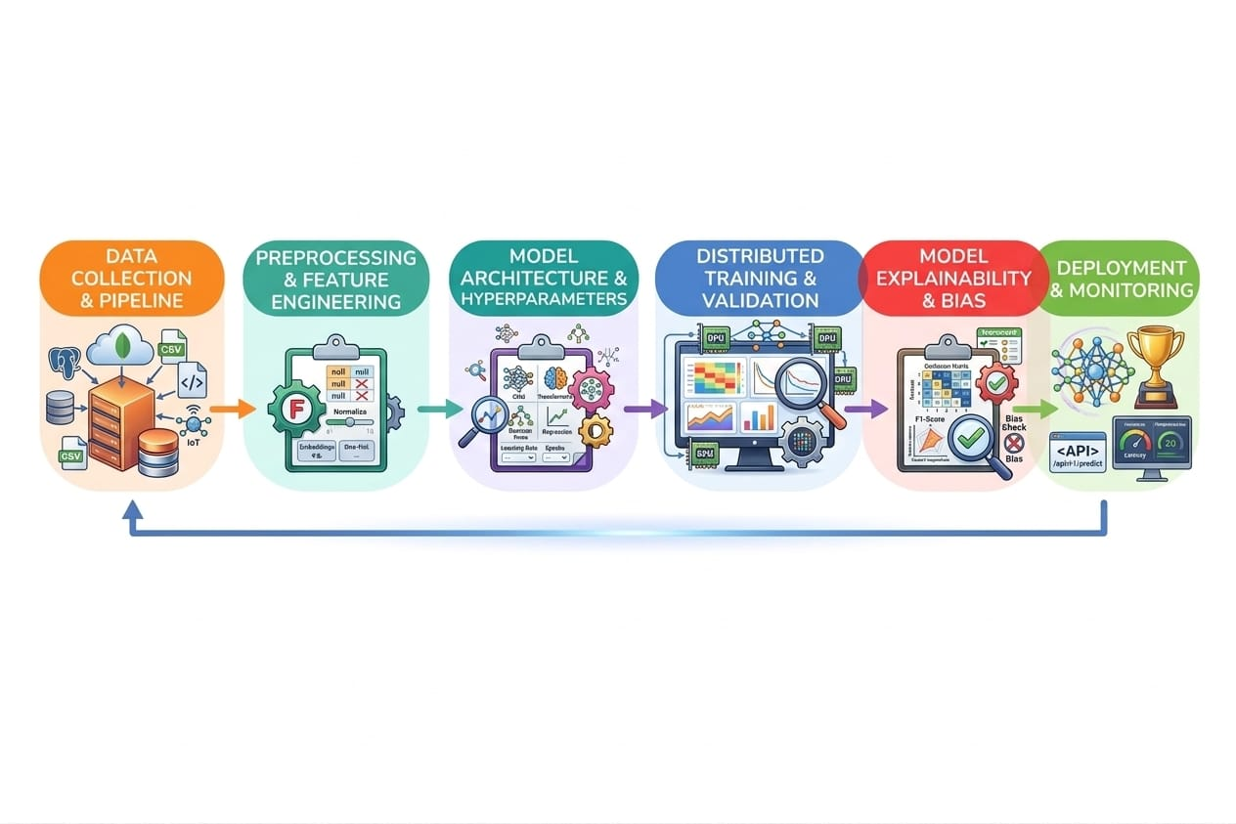

- Expected Modules/ Libraries to be used :
1 pandas – For loading, exploring, and manipulating datasets in table (DataFrame) format.
2 numpy – Provides fast numerical operations and array handling for calculations.
3 matplotlib.pyplot – Used to create basic plots like histograms, scatter plots, and box plots.
4 seaborn – High-level visualization library for heatmaps, correlation plots, and improved aesthetics.
5 scikit-learn (sklearn) – Main machine learning library, providing models, preprocessing, and evaluation tools:
- train_test_split – Splits dataset into training and testing sets.
- LinearRegression – Builds simple linear regression models.
- DecisionTreeRegressor – Builds tree-based regression models.
- RandomForestRegressor – Ensemble model for better prediction accuracy.
- MinMaxScaler – Scales numerical features to a uniform range (0–1).
- PCA – Optional feature reduction while keeping most variance.
- SequentialFeatureSelector – Optional forward/backward feature selection.
5 warnings – Handles runtime warnings that may appear during data processing or model training.
- Expected Evaluation metrics and Plots to be used:
For Regression (Exam Score Prediction):
- Mean Absolute Error (MAE): Measures the average absolute difference between predicted and actual scores. It is simple to interpret and provides a direct sense of prediction error.
- Mean Squared Error (MSE): Calculates the average squared difference between predicted and actual scores, giving more weight to larger errors.
- R² Score (Coefficient of Determination): Indicates how much of the variance in exam scores is explained by the model, showing overall predictive power.
For Optional Classification (Pass/Fail Prediction):
- Accuracy: Percentage of correctly predicted pass/fail outcomes.
- Precision: Measures how many students predicted to pass actually passed.
- Recall: Measures how many actual passing students were correctly identified.
- F1 Score: Combines precision and recall into a single metric, balancing both.
Expected Plots
- Histogram: Displays the distribution of exam scores.
- Scatter Plot: Shows relationships between key features (e.g., hours studied, attendance) and exam scores.
- Heatmap: Visualizes correlations between features and the target variable.
- Residual Plot: Compares predicted versus actual scores to assess model fit.
- Feature Importance Bar Plot: Highlights which features contribute most to predictions.
- Box Plots: Helps detect outliers and examine the distribution of individual features.
These metrics and visualizations provide a comprehensive understanding of model performance, reveal patterns in the data, and identify the most influential factors affecting student performance.

- Required topics from the subject:
- Strings:
Handled categorical data such as attendance and tutoring sessions. These text features were converted into numeric form using encoding techniques for machine learning.
- Files:
Used to read the student dataset (CSV/Excel) and save processed data or predictions. File operations were essential for data input and output.
- Arrays / Lists:
Stored features and labels before feeding them into models and iterated through dataset rows during preprocessing.
- Functions:
Custom functions were created for tasks like data cleaning, encoding, scaling, model training, and evaluation metric calculations.
- DataFrames / Structures:
pandas DataFrame was used to organize the dataset, making it easy to manipulate columns, select features, and perform analysis.
- Platform Required:
- The project can be developed and executed using Jupyter Notebook, Python IDLE, or Visual Studio Code. These platforms provide support for Python programming, data analysis libraries (like pandas and scikit-learn), and visualization tools for implementing machine learning models efficiently.
- Books and Link Sources:
- “Python Machine Learning” by Sebastian Raschka – Covers data preprocessing, machine learning algorithms, and model evaluation.
- “Hands-On Machine Learning with Scikit-Learn, Keras, and TensorFlow” by Aurélien Géron – Practical guide for regression, classification, and ML workflows.
- “Data Science from Scratch” by Joel Grus – Explains data manipulation, feature engineering, and model building in Python.
- “Introduction to Machine Learning with Python” by Andreas C. Müller and Sarah Guido – Focuses on scikit-learn, including regression, feature selection, and evaluation metrics.
Online Links / Sources:
- Scikit-learn Documentation – Official guide for machine learning algorithms, preprocessing, and metrics.
- Pandas Documentation – Reference for data handling and DataFrame operations.
- Kaggle Datasets – Source for student performance datasets used for analysis and modeling.
- Towards Data Science – ML Tutorials – Practical tutorials on regression, classification, and data visualization.

